**Creating Microservices for account and loan**

AccountApplication

package com.cognizant.account;

import org.springframework.boot.SpringApplication;

import org.springframework.boot.autoconfigure.SpringBootApplication;

@SpringBootApplication

public class AccountApplication {

public static void main(String[] args) {

SpringApplication.*run*(AccountApplication.class, args);

}

}

AccountController.java

**package** com.cognizant.account.controller;

**import** org.springframework.web.bind.annotation.GetMapping;

**import** org.springframework.web.bind.annotation.PathVariable;

**import** org.springframework.web.bind.annotation.RestController;

**import** java.util.HashMap;

**import** java.util.Map;

@RestController

**public** **class** AccountController {

@GetMapping("/accounts/{number}")

**public** Map<String, Object> getAccountDetails(@PathVariable String number) {

Map<String, Object> account = **new** HashMap<>();

account.put("number", number);

account.put("type", "savings");

account.put("balance", 234343);

**return** account;

}

}

Output:

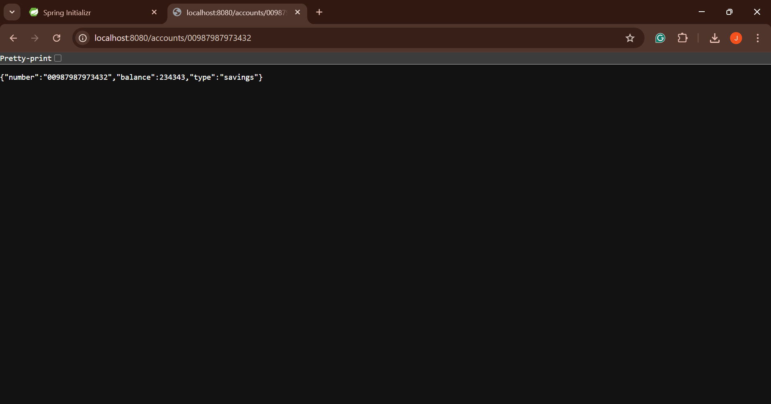

LoanController

**package** com.cognizant.loan.controller;

**import** org.springframework.web.bind.annotation.GetMapping;

**import** org.springframework.web.bind.annotation.PathVariable;

**import** org.springframework.web.bind.annotation.RestController;

**import** java.util.HashMap;

**import** java.util.Map;

@RestController

**public** **class** LoanController {

@GetMapping("/loans/{number}")

**public** Map<String, Object> getLoanDetails(@PathVariable String number) {

Map<String, Object> loan = **new** HashMap<>();

loan.put("number", number);

loan.put("type", "car");

loan.put("loan", 400000);

loan.put("emi", 3258);

loan.put("tenure", 18);

**return** loan;

}

}

application.properties

spring.application.name=loan

server.port=8081

LoanApplication

**package** com.cognizant.loan;

**import** org.springframework.boot.SpringApplication;

**import** org.springframework.boot.autoconfigure.SpringBootApplication;

@SpringBootApplication

**public** **class** LoanApplication {

**public** **static** **void** main(String[] args) {

SpringApplication.*run*(LoanApplication.**class**, args);

}

}

Output:

